Screen 1: COO Executive Dashboard
This is the first thing your COO sees every morning — a single-page status of the entire business. It contains five layers:
- Top KPIs — Total Billed, Total Collected, Pending $, Follow-Up item count, and Collection Rate vs. target. These update automatically whenever a new remittance file is ingested.
- Billed vs. Paid bar chart — 12 rolling weeks side by side (Billed / Collected / Pending) so the COO can see if the gap is growing or shrinking over time.
- Follow-Up donut — breaks down why money is pending: Paid with Exception, Denied, Underpaid, Not Yet Paid, Recoupment. This tells the COO whether the problem is a billing issue, an authorization issue, or a payer behavior issue.
- Insurance payer performance — horizontal bars showing collection rate per payer (UHC, Sentara, Aetna, Molina, etc.). Green = hitting target, yellow = borderline, red = problem payer.
- Top open balances table — the five biggest unpaid amounts with client name, gap $, and color-coded status. One glance tells the COO exactly which clients need attention.
The COO never needs to touch a spreadsheet — they just open this URL.

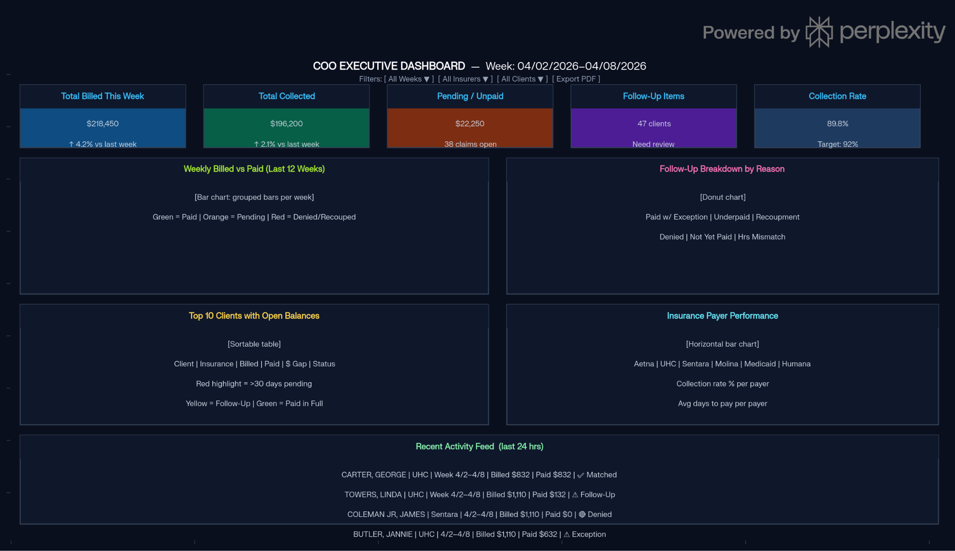

Screen 2: Billing Analyst Workbench
This replaces your current weekly recon Excel file as the working surface for the analyst. It is organized around the analyst's actual workflow:
- Filters at the top — Service week picker, insurance filter, and a "Follow-Up Only" toggle. When that toggle is on, the queue shrinks from 312 rows to only the 47 items that need action — exactly what your current Excel highlight does, but automatically.
- Follow-Up Queue — a sortable list showing Client, Insurer, Billed, Paid, $Gap, Hrs Δ, the reason (Exception / Denied / UC Rate), and two action buttons: [Review] (opens the Trizetto link or shows the claim detail) and [Rebill] (pushes the item to the Rebilling Tracker with one click).
- Rebilling Tracker panel — shows every item currently sent for rebill, the denial code that caused it, when it was rebilled, and current status. This replaces your separate manual rebilling tracker spreadsheet.
- Client Detail sidebar — clicking any row in the queue shows the full client snapshot on the right: insurance, aide assigned that week, authorized hours, payroll cost, net margin, and TCN. The analyst never needs to go look this up manually.
- AI Assistant strip at the bottom — the analyst can type "Which Sentara claims were denied this month?" or "What is still pending from week 2/18?" and get an answer in plain English, sourced from the actual data.

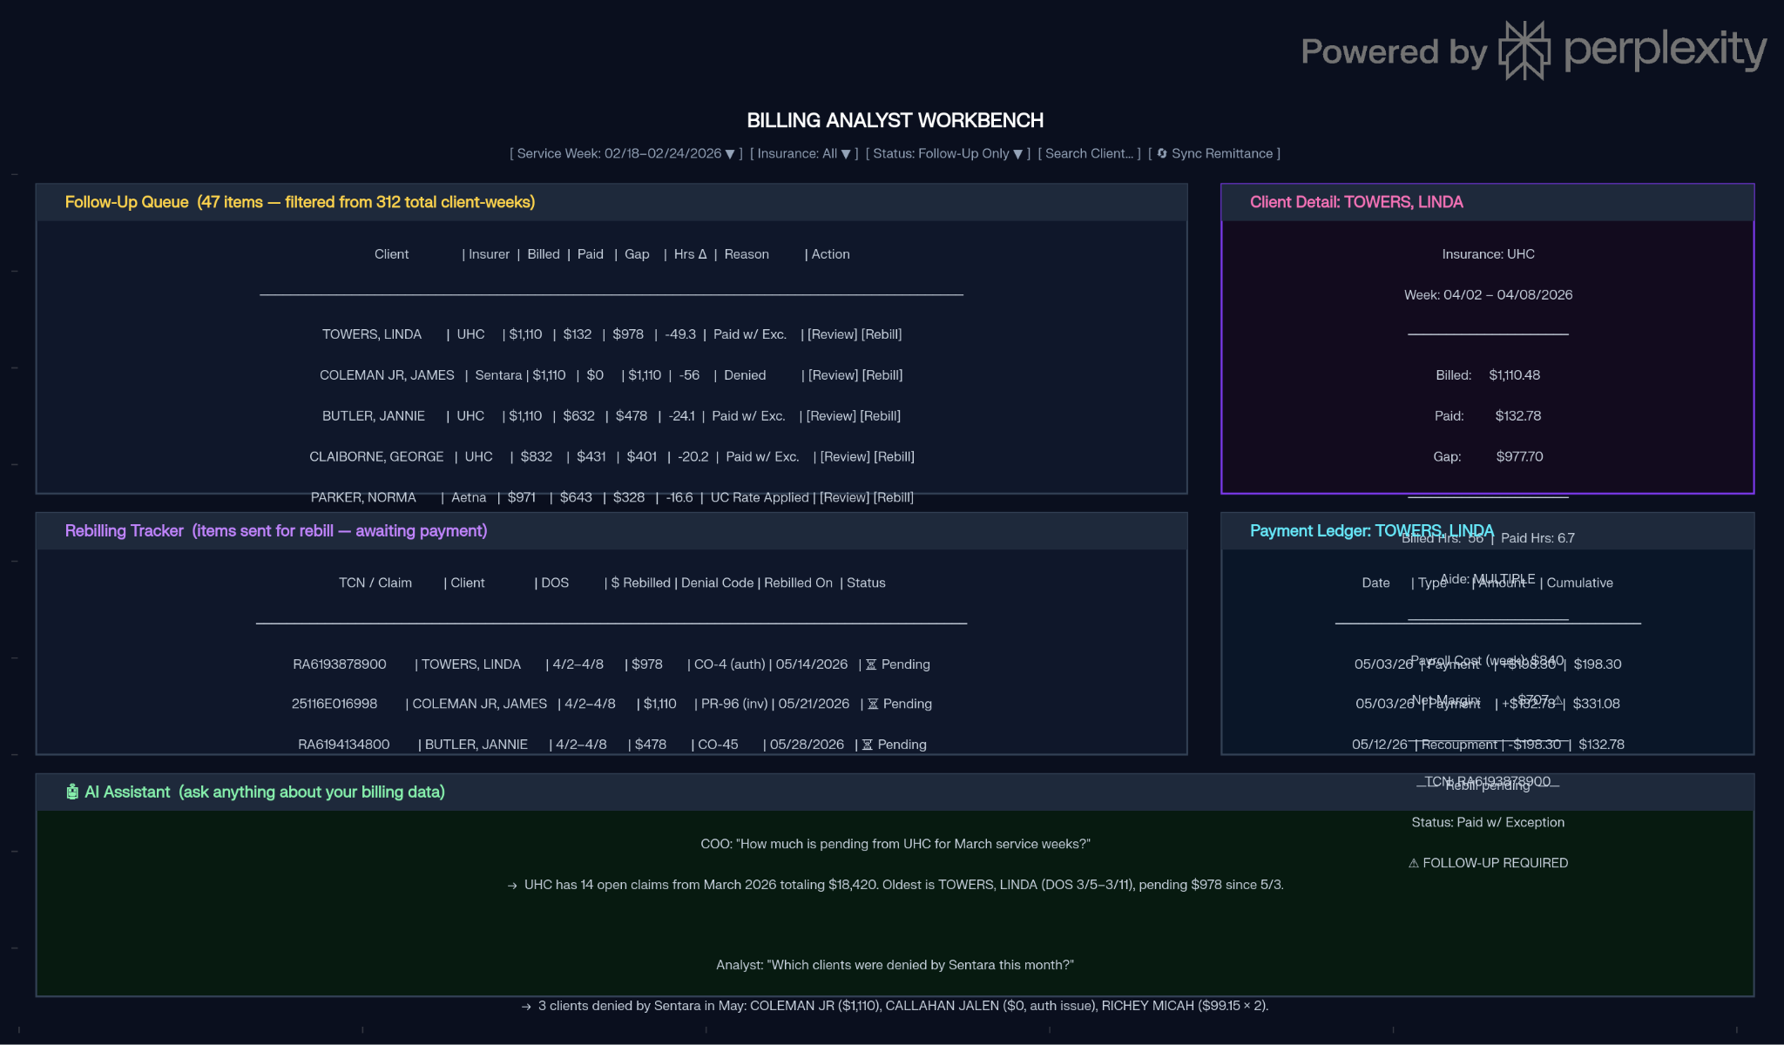
Screen 3: Client Ledger Drill-Down
This is the "rock bottom" view you asked for — every single payment, positive or negative, for one client across all service weeks. It has three parts:
- Weekly trend bar chart — all 52 weeks of billed vs. paid for that client. Immediately reveals if a client has a chronic underpayment pattern (like TOWERS, LINDA) or was only recently affected.
- Client summary card — authorized hours, current aide(s), YTD billed, YTD collected, YTD pending, collection rate, and open claim count. This is the "golden record" for that client in one card.
- Full payment ledger table — every transaction in chronological order: date, batch #, TCN, DOS (service week), transaction type (Payment / Recoupment / Rebill), amount charged, amount received, and status. Negative rows (recoupments/clawbacks) appear in red so they're immediately visible.

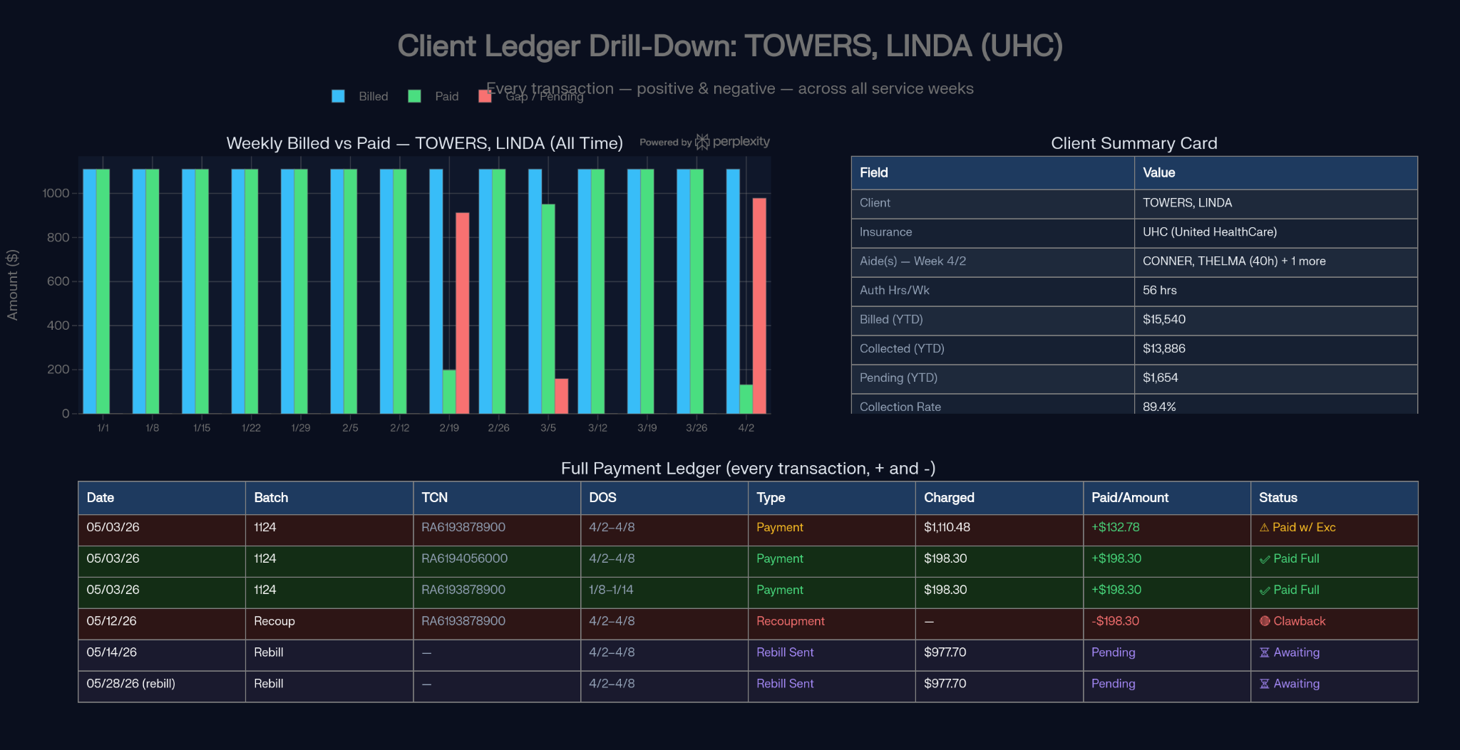

Screen 4: AI Chat (Natural Language Q&A)
This is a simple chat interface accessible to everyone — COO, COO, billing analyst — with no training required. It connects directly to the Golden Record database and answers questions like:

Who Asks | Example Question | What They Get
COO | "How much are we owed from UHC for Q1?" | Exact dollar amount + count of open claims
COO | "Is our collection rate improving?" | Trend answer with the last 8 weeks of data
Analyst | "Which clients have hours denied by Sentara?" | List with claim #s and denial codes
Analyst | "Show me everything open for TOWERS, LINDA" | Full ledger summary
Analyst | "What denial codes are most common this month?" | Ranked list with $ impact

System Architecture
Four data sources feed a single Python ETL pipeline. The ETL normalizes client names, deduplicates remittance rows by TCN, and writes everything into a single DuckDB file on your server. The Streamlit app then exposes four screens on top of that.
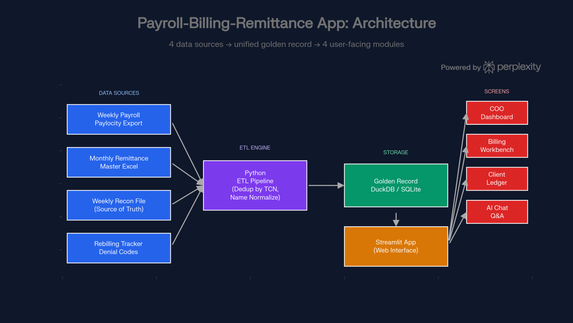

The Data Update Lifecycle
The key design principle is that you never manually copy-paste again:
- Every Friday after payroll runs → drop the new payroll Excel in a folder → Python auto-ingests it in under 30 seconds
- Once a month after remittance download → drop the master remittance Excel in the same folder → Python deduplicates by TCN and updates every affected client record
- When a rebill is resolved → the next remittance drop automatically picks up the new payment and closes the rebilling tracker item

Phase 1: Manual Ingest (Build Now)
This is what we build first. Your team drops files into a watched folder (or Google Drive folder), and the app picks them up. No SFTP, no 835 parsing yet. Specifically:
- Payroll: Drop the weekly EmpTimeCardReport-PY-MMDDYYYY.xlsx into a folder → ETL ingests it
- Remittance: Drop the monthly master remittance Excel (like V5.1-2026-Remittance...xlsx) into a folder → ETL ingests it
- Weekly Recon: The Payroll-Billing-Remittance file becomes the seed to bootstrap historical data and validate that the app's calculations match what Yash and Ms. Connie already computed manually
- Name Match table: Loaded from the Name Match sheet and maintained inside the app going forward
The golden record is built from these three sources. Everything else — dashboards, analyst workbench, AI Q&A — runs on top of this.

Phase 2: Automated Ingest (Future Project)
This is a separate, well-scoped project with its own testing pipeline:

Component | What's Needed
Google Drive → Payroll | Google Drive API (service account), watch a specific folder, download new files weekly on payroll run day
Trizetto SFTP → 835 files | SFTP client (Python paramiko), scheduled pull, download new .remit / EDI 835 files
835 Parser | EDI 835 is a structured format — parse CLP, SVC, CAS, REF segments to extract claim #, TCN, paid amount, denial codes, adjustment reasons
835 → Master Remittance converter | Transform parsed 835 data into the same column format as your current master Excel — this is what replaces the manual monthly download
Dedup + Delta detection | Since remittance comes in batches and can overlap, compare new 835 against existing golden record by TCN — only update changed records
Testing harness | Run Phase 2 output side-by-side with Phase 1 manual output for 2–3 weeks to validate they match before switching over

The 835 parsing is the most technically involved piece — denial codes live in CAS segments (CO-45, PR-96, etc.) and those map directly to your "Follow Up" reason codes.

